**Tugas Pertemuan Ke – 9**

**Bab 9 : REST API**

|  |  |
| --- | --- |
| **Nama** | Alfina |
| **Nim** | 2018041 |
| **Kelas** | B |
| **Pemberi Tugas** | Alfin Ardiansyah (2118124) |

1. **Melanjutkan projek sesuai tema dengan mengimplementasikan RestAPI dengan cara GET saja dan tambahkan menu pada action bar atau navigation bar. Boleh menggunakan URL Public atau ApiKey yang bisa didapatkan darimana saja lalu diterapkan pada layout android. Pastikan tampilan IU yang dibuat sebagus dan sekreatif mungkin.**
2. **Langkah – langkah pengerjaan**
3. Membuat *project* baru pada Android Studio dengan memilih *New Projec*t seperti pada gambar dibawah

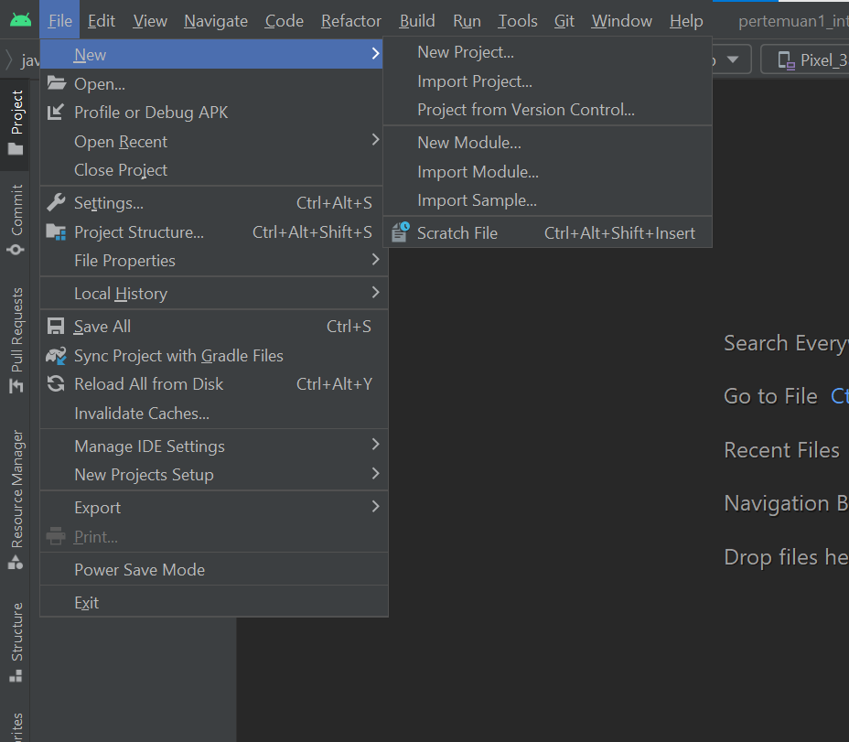

#### Halaman Awal Android Studio

1. Praktikan memilih “*Empy Activity*” pada “*Phone and Tablet*” seperti pada gambar dibawah

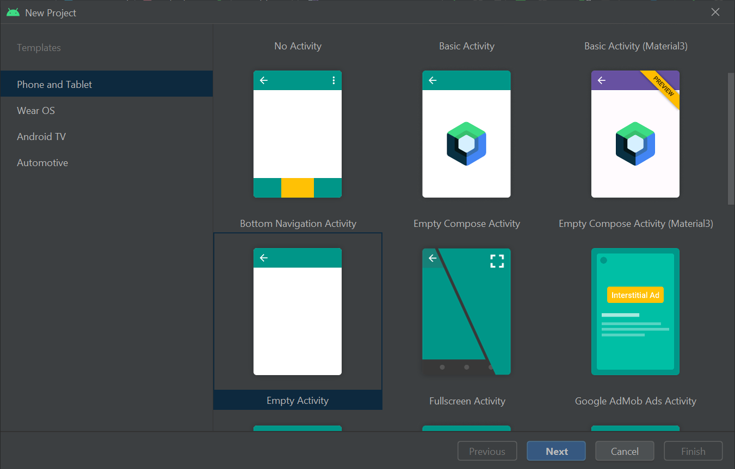

#### *Empty Activity* pada *Phone and Tablet*

1. Mengisi identitas project seperti pada gambar. Disarankan memakai minimum SDK 27 ( Android 8.1 Oreo ). Jika sudah klik *finish*

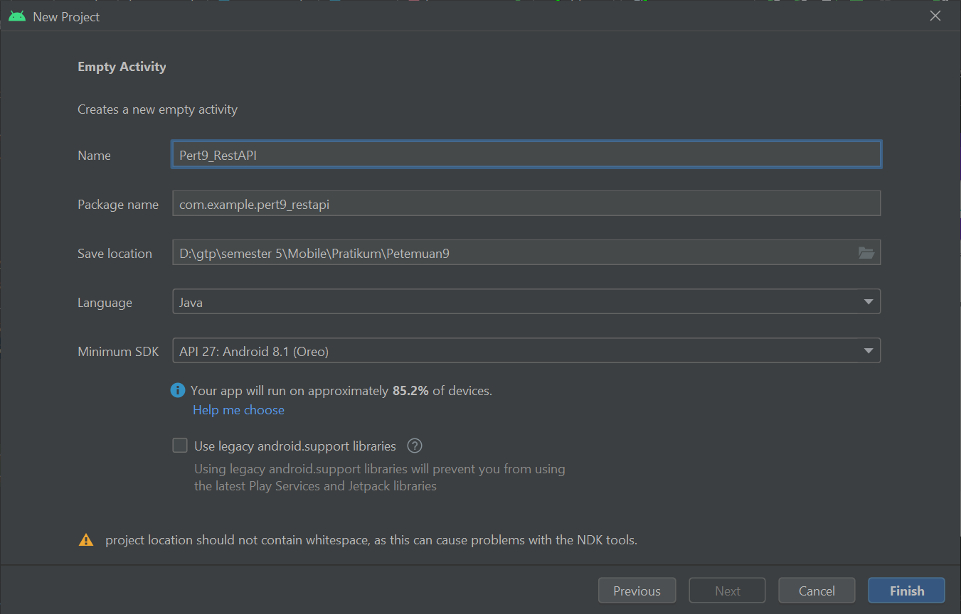

#### Mengisi Identitas *Project*

1. Kemudian double klik pada build.gradle

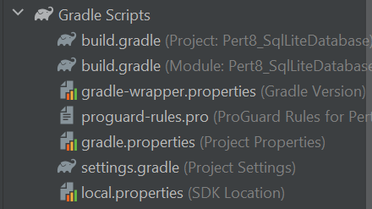

#### Build Gradle

1. Kemudian tambahkan library seperti gambar dibawah ini lalu klik “Sync Now” pada pop up gradle yang akan muncul.

Source code

|  |
| --- |
| //activation binding view  buildFeatures{  viewBinding true  } |

*Source code* di atas adalah *source code* pada *Gradle Script* yang digunakan untuk menambahkan *library* sesuai kebutuhan.

1. Kemudian double file AndroidManifest.xml, lalu tambahkan kode seperti gambar dibwah ini.

Source code

|  |
| --- |
| <?xml version="1.0" encoding="utf-8"?>  <manifest xmlns:android="http://schemas.android.com/apk/res/android"  xmlns:tools="http://schemas.android.com/tools"  package="com.example.pert9_restapi">  <uses-permission android:name="android.permission.CAMERA" />  <uses-permission android:name="android.permission.READ_EXTERNAL_STORAGE" />  <uses-permission android:name="android.permission.WRITE_EXTERNAL_STORAGE" />  <uses-permission android:name="android.permission.INTERNET"/>  <application  android:allowBackup="true"  android:dataExtractionRules="@xml/data_extraction_rules"  android:fullBackupContent="@xml/backup_rules"  android:icon="@mipmap/ic_launcher"  android:label="@string/app_name"  android:roundIcon="@mipmap/ic_launcher_round"  android:supportsRtl="true"  android:theme="@style/Theme.Pert8_SqlLiteDatabase"  tools:targetApi="31">  <activity  android:name=".MainActivity6"  android:exported="false" />  <activity  android:name=".DisplayData"  android:exported="false" />  <activity  android:name=".MainActivity5"  android:exported="false" />  <activity  android:name=".MainActivity4"  android:exported="false" />  <activity  android:name=".MainActivity3"  android:exported="false" />  <activity  android:name=".MainActivity2"  android:exported="false" />  <activity  android:name=".MainActivity"  android:exported="true">  <intent-filter>  <action android:name="android.intent.action.MAIN" />  <category android:name="android.intent.category.LAUNCHER" />  </intent-filter>  </activity>  <receiver android:name=".AlarmReceiver" />  <activity android:name="com.theartofdev.edmodo.cropper.CropImageActivity" />  </application>  </manifest> |

1. Kemudian membuat java class baru dengan cara klik kanan pada com.example > new > Java Class.

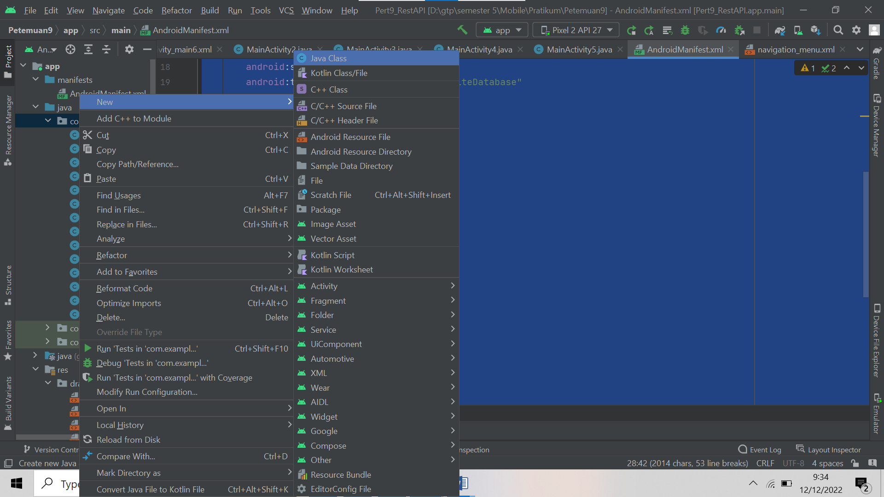

#### Membuat Class Java Baru

1. Kemudian berikan identitas java class seperti pada gambar dibawah ini.

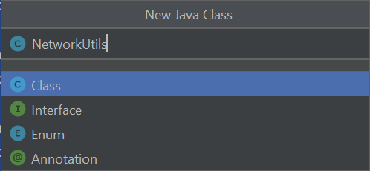

#### Identitas Java Class Baru

1. Double klik pada NetworkUtlis.java kemudian tambahkan source code berikut.

Source code

|  |
| --- |
| package com.example.pert9_restapi;  import java.io.IOException;  import java.io.InputStream;  import java.net.HttpURLConnection;  import java.net.URL;  import java.util.Scanner;  public class NetworkUtils {  public static String makeHTTPRequest(URL url) throws  IOException {  //connection http URL  HttpURLConnection connection = (HttpURLConnection)  url.openConnection();  InputStream inputStream = connection.getInputStream();  try {  Scanner scanner = new Scanner(inputStream);  scanner.useDelimiter("\\A");  boolean hasInput = scanner.hasNext();  if (hasInput)  return scanner.next();  else return null;  } finally {  connection.disconnect();  }  }  } |

Analisa :

*Source code* di atas adalah *source code* pada class NetworkUtils yang bertipe file java. *Source code* digunakan untuk membuat koneksi pada url dengan android studionya agar bisa mengambil data dari internetnya.

1. Kemudian tambahkan source code berikut pada activity_main6.xml.

Source code

|  |
| --- |
| <?xml version="1.0" encoding="utf-8"?>  <LinearLayout  xmlns:android="http://schemas.android.com/apk/res/android"  xmlns:app="http://schemas.android.com/apk/res-auto"  xmlns:tools="http://schemas.android.com/tools"  android:layout_width="match_parent"  android:layout_height="match_parent"  android:orientation="vertical"  android:padding="16dp"  tools:context=".MainActivity">  <EditText  android:id="@+id/input_id"  android:layout_width="match_parent"  android:layout_height="wrap_content"  android:hint="ID Product"  android:inputType="textPersonName"  android:textSize="16sp"/>  <Button  android:id="@+id/fetch_button"  android:layout_width="match_parent"  android:layout_height="wrap_content"  android:text="Fetch"  android:textAllCaps="true"  android:textSize="16sp" />  <LinearLayout  android:layout_width="match_parent"  android:layout_height="420dp"  android:background="#eceff1"  android:orientation="horizontal">  <LinearLayout  android:layout_width="wrap_content"  android:layout_height="match_parent"  android:orientation="vertical"  android:layout_marginLeft="8dp"  android:layout_marginTop="8dp">  <TextView  android:layout_width="wrap_content"  android:layout_height="wrap_content"  android:layout_weight="1"  android:text="ID" />  <TextView  android:layout_width="wrap_content"  android:layout_height="wrap_content"  android:layout_weight="1"  android:text="Created At" />  <TextView  android:layout_width="wrap_content"  android:layout_height="wrap_content"  android:layout_weight="1"  android:text="Updated At" />  <TextView  android:layout_width="wrap_content"  android:layout_height="wrap_content"  android:layout_weight="1"  android:text="Name" />  <TextView  android:layout_width="wrap_content"  android:layout_height="wrap_content"  android:layout_weight="10"  android:text="Description" />  <TextView  android:layout_width="wrap_content"  android:layout_height="wrap_content"  android:layout_weight="1"  android:text="Qty" />  <TextView  android:layout_width="wrap_content"  android:layout_height="wrap_content"  android:layout_weight="1"  android:text="Price" />  <TextView  android:layout_width="wrap_content"  android:layout_height="wrap_content"  android:layout_weight="2"  android:text="Image" />  <TextView  android:layout_width="wrap_content"  android:layout_height="wrap_content"  android:layout_weight="1"  android:text="Rating" />  </LinearLayout>  <LinearLayout  android:layout_width="wrap_content"  android:layout_height="match_parent"  android:orientation="vertical"  android:layout_marginLeft="8dp"  android:layout_marginTop="8dp">  <TextView  android:layout_width="wrap_content"  android:layout_height="wrap_content"  android:layout_weight="1"  android:text=":" />  <TextView  android:layout_width="wrap_content"  android:layout_height="wrap_content"  android:layout_weight="1"  android:text=":" />  <TextView  android:layout_width="wrap_content"  android:layout_height="wrap_content"  android:layout_weight="1"  android:text=":" />  <TextView  android:layout_width="wrap_content"  android:layout_height="wrap_content"  android:layout_weight="1"  android:text=":" />  <TextView  android:layout_width="wrap_content"  android:layout_height="wrap_content"  android:layout_weight="10"  android:text=":" />  <TextView  android:layout_width="wrap_content"  android:layout_height="wrap_content"  android:layout_weight="1"  android:text=":" />  <TextView  android:layout_width="wrap_content"  android:layout_height="wrap_content"  android:layout_weight="1"  android:text=":" />  <TextView  android:layout_width="wrap_content"  android:layout_height="wrap_content"  android:layout_weight="2"  android:text=":" />  <TextView  android:layout_width="wrap_content"  android:layout_height="wrap_content"  android:layout_weight="1"  android:text=":" />  </LinearLayout>  <LinearLayout  android:layout_width="match_parent"  android:layout_height="match_parent"  android:orientation="vertical"  android:layout_marginLeft="8dp"  android:layout_marginTop="8dp">  <TextView  android:id="@+id/result_id"  android:layout_width="match_parent"  android:layout_height="wrap_content"  android:layout_weight="1" />  <TextView  android:id="@+id/result_created"  android:layout_width="match_parent"  android:layout_marginTop="10dp"  android:layout_height="wrap_content"  android:layout_weight="1" />  <TextView  android:id="@+id/result_updated"  android:layout_marginTop="10dp"  android:layout_width="match_parent"  android:layout_height="wrap_content"  android:layout_weight="1" />  <TextView  android:id="@+id/result_name"  android:layout_marginTop="10dp"  android:layout_width="match_parent"  android:layout_height="wrap_content"  android:layout_weight="1" />  <TextView  android:id="@+id/result_description"  android:layout_width="match_parent"  android:layout_height="wrap_content"  android:layout_marginTop="10dp"  android:layout_weight="9" />  <TextView  android:id="@+id/result_qty"  android:layout_marginBottom="9dp"  android:layout_width="match_parent"  android:layout_height="wrap_content"  android:layout_weight="1" />  <TextView  android:id="@+id/result_price"  android:layout_marginBottom="10dp"  android:layout_width="match_parent"  android:layout_height="wrap_content"  android:layout_weight="1" />  <TextView  android:id="@+id/result_image"  android:layout_marginBottom="5dp"  android:layout_width="match_parent"  android:layout_height="wrap_content"  android:layout_weight="2" />  <TextView  android:id="@+id/result_rating"  android:layout_marginBottom="7dp"  android:layout_width="match_parent"  android:layout_height="wrap_content"  android:layout_weight="1" />  </LinearLayout>  </LinearLayout>  </LinearLayout> |

### Tabel Komponen activity_main5.xml

|  |  |  |  |
| --- | --- | --- | --- |
| **No** | **Object** | **Property** | **Value** |
|  | PlainText | Id  InputType | @+id/input_id  ID Lagu |
|  | Button1 | Id  Text | @+id/fetch_button  Fecth |
|  | EditText1 | Id  InputType | @+id/edtartis  ID |
|  | EditText2 | Id  InputType | @+id/edtartis  Title |
|  | EditText3 | Id  InputType | @+id/edtartis  Thumbnail |
|  | EditText4 | Id  InputType | @+id/edtartis  Poster |
|  | EditText5 | Id  InputType | @+id/edtartis  Hi |
|  | EditText6 | Id  InputType | @+id/edtartis  Med |
|  | EditText7 | Id  InputType | @+id/edtartis  Low |

1. Kemudian tambahkan source code berikut pada MainActivity6.java

Source code

|  |
| --- |
| package com.example.pert9_restapi;  import androidx.appcompat.app.AppCompatActivity;  import android.net.Uri;  import android.os.AsyncTask;  import android.os.Bundle;  import android.view.View;  import com.example.pert9_restapi.databinding.ActivityMain6Binding;  import org.json.JSONArray;  import org.json.JSONException;  import org.json.JSONObject;  import java.io.IOException;  import java.net.MalformedURLException;  import java.net.URL;  public class MainActivity6 extends AppCompatActivity implements  View.OnClickListener{  //declaration variable  private ActivityMain6Binding binding;  String index;  @Override  protected void onCreate(Bundle savedInstanceState) {  super.onCreate(savedInstanceState);  //setup view binding  binding = ActivityMain6Binding.inflate(getLayoutInflater());  setContentView(binding.getRoot());  binding.fetchButton.setOnClickListener(this);  }  //onclik button fetch  @Override  public void onClick(View v) {  if(v.getId() == R.id.fetch_button){  index = binding.inputId.getText().toString();  try {  getData();  } catch (MalformedURLException e) {  e.printStackTrace();  }  }  }  //get data using api link  public void getData() throws MalformedURLException {  Uri uri = Uri.parse("https://gist.githubusercontent.com/lukebaker/1040981/raw/07fbd3e76d9a9f19c2cca143b892c6985c5632a4/playlist-sample.json").buildUpon().build();  URL url = new URL(uri.toString());  new DOTask().execute(url);  }  class DOTask extends AsyncTask<URL, Void, String>{  //connection request  @Override  protected String doInBackground(URL... urls) {  URL url = urls [0];  String data = null;  try {  data = NetworkUtils.makeHTTPRequest(url);  }catch (IOException e){  e.printStackTrace();  }  return data;  }  @Override  protected void onPostExecute(String s){  try {  parseJson(s);  } catch (JSONException e) {  e.printStackTrace();  }  }  //get data json  public void parseJson(String data) throws JSONException{  JSONObject jsonObject = null;  try {  jsonObject = new JSONObject(data);  }catch (JSONException e){  e.printStackTrace();  }  JSONObject innerObj = jsonObject.getJSONObject("playlist");  JSONArray cityArray = innerObj.getJSONArray("videos");  for (int i =0; i <cityArray.length(); i++){  JSONObject obj = cityArray.getJSONObject(i);  String Sobj = obj.get("id").toString();  if (Sobj.equals(index)){  // String name = obj.get("name").toString();  // binding.resultName.setText(name);  // break;  String id = obj.get("title").toString();  binding.resultId.setText(id);  String created_at = obj.get("thumbnail").toString();  binding.resultCreated.setText(created_at);  String updated_at = obj.get("poster").toString();  binding.resultUpdated.setText(updated_at);  String name = obj.get("hi").toString();  binding.resultName.setText(name);  String description = obj.get("med").toString();  binding.resultDescription.setText(description);  String qty = obj.get("low").toString();  binding.resultQty.setText(qty);  // String price = obj.get("price").toString();  // binding.resultPrice.setText(price);  // String rating = obj.get("rating").toString();  // binding.resultRating.setText(rating);  // String image = obj.get("image").toString();  // binding.resultImage.setText(image);  break;  }  else{  binding.resultName.setText("Not Found");  }  }  }  }  } |

Analisa :

*Source code* di atas adalah *source code* pada class MainActivity6 yang betipe file java. *Source code* di atas berguna untuk menjalankan apa yang sudah dibuat pada activity_main6.xml nya. Terdapat pemberian api link agar dapat mengambil data json dari internet dengan isi yang sudah disesuaikan*.*

1. Hasil running program

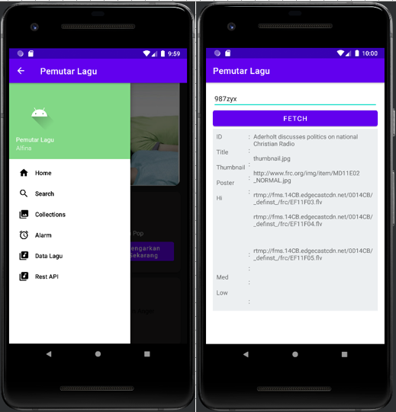

#### Hasil Running Program

1. **Link repository github**

https://github.com/Alfina041/Tugas8_2018041.git